Kiosk Lockdown Procedure
  - Configuring SiteKiosk
Version 1.0
March 31, 2022

Contents
Prerequisites 2
Configuring SiteKiosk 2
Licensing SiteKiosk 2
Applying the Standard Configuration 2
ESC Password 3
Start Page 3
Screensaver 4
Applications 4
On-Screen Keyboard 5
System Security Manager Settings 5

Prerequisites
Configuring SiteKiosk should be performed once all dependencies of the FrontEdge CheckInKiosk has been completed per the Kiosk Software Installation steps in KioskScannerSetup.docx.
This includes:
- DotNetFX472
- POS for DotNET
- Posiflex OPOS Controls
- SQL LocalDB 2019
- WebView2Runtime
- FrontEdge CheckInKiosk

Configuring SiteKiosk
First, launch Configure SiteKiosk from the Start menu
Licensing SiteKiosk  Register the application using the Registration button in the top-right corner of the window.  To register, input the license Name and Code from a SiteKiosk License Certificate. These can be found in the Provisio vendor folder on SharePoint here. Then click Register.  Save the configuration using the Save As button to C:\Program Files (x86)\SiteKiosk\Config\  and name the file sitekiosk_standard_config.skcfg | 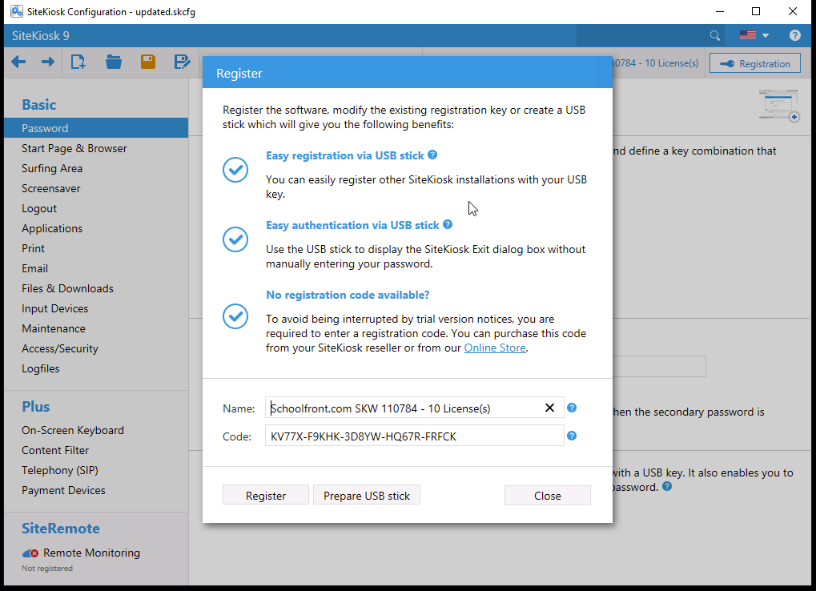

Applying the Standard Configuration
A standard configuration has been developed that can be applied by overwriting the saved configuration from above. The configuration file can be found here. Close out of all SiteKiosk windows and overwrite the file in C:\Program Files (x86)\SiteKiosk\Config with the sitekiosk_standard_config.skcfg file.
By applying the standard configuration you can skip the additional steps in this section.
Note: You must still execute the steps in the System Security Manager Settings section

ESC Password  To exit out of SiteKiosk or to make changes to its configuration while running it is necessary to configure a password. This prevents unauthorized users from attempting to modify SiteKiosk or to exit into the operating system. | 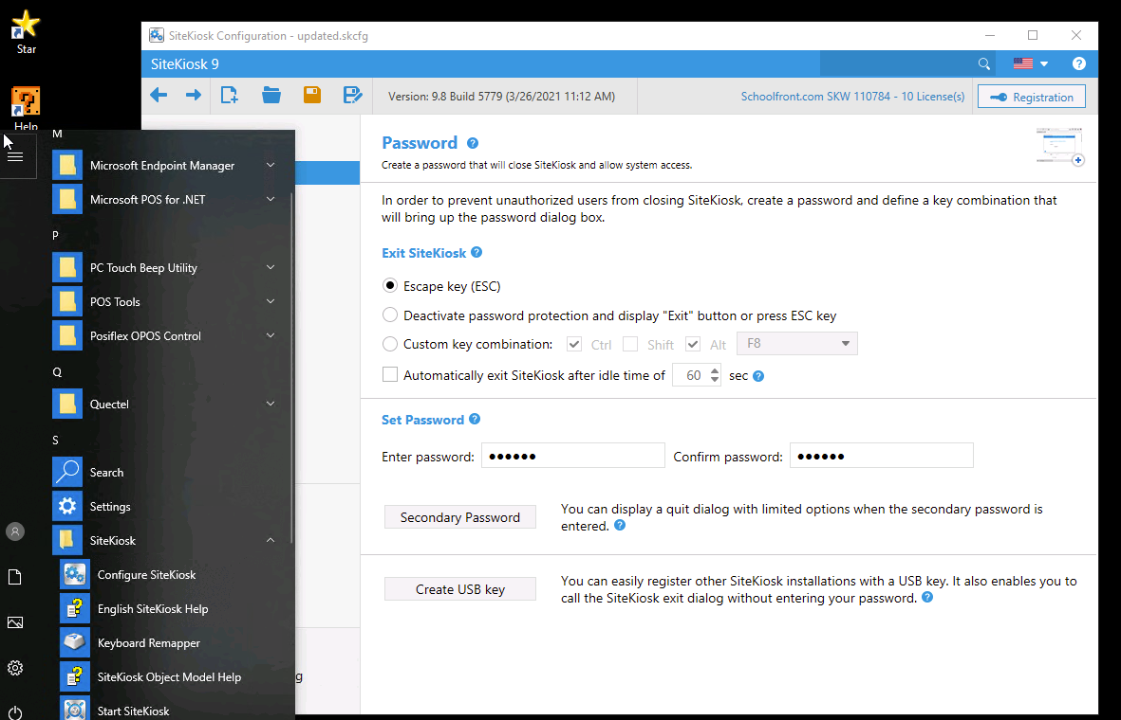
Start Page  Configure the SiteKiosk Start Page to Desktop Startpage. | 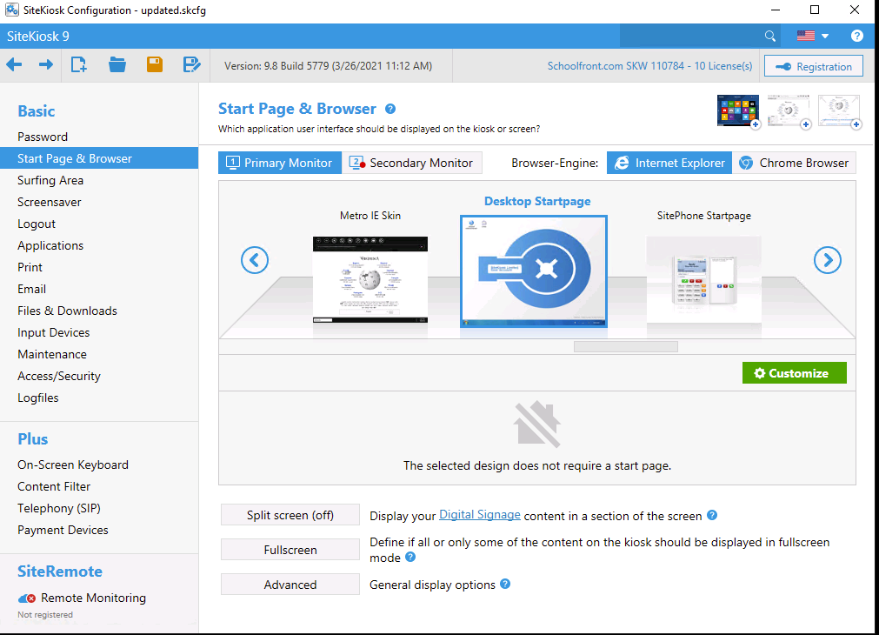
Screensaver  Ensure that the screensaver is disabled | 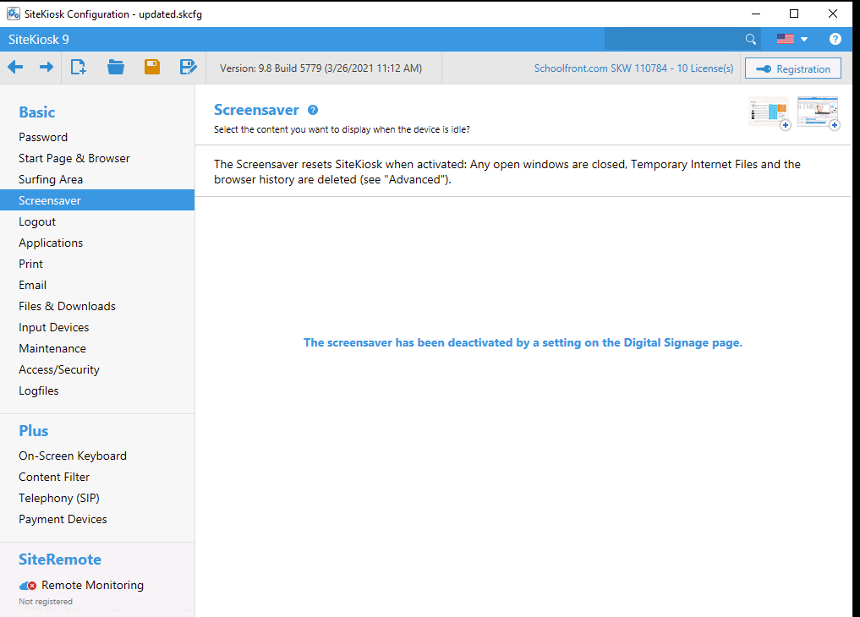

Application  Configure SiteKiosk to automatically launch the FrontEdge Check-in Kiosk application on startup.  On the Start Page & Browser screen click the Advanced button. On the Advanced Settings screen, scroll down to the Execute Script section and check the checkbox to start a script on startup.  Supply the following path to run the app_watchdog.js file at startup. If this file does not exist, please contact SchoolFront support. This will launch the Check-in Kiosk software at startup, restart it if it crashes and closes and will ensure it stays maximized on the display. |  | 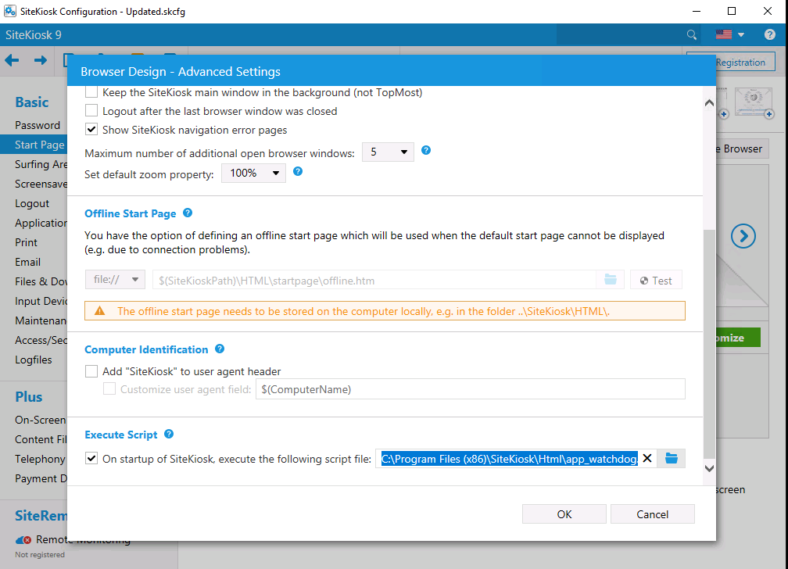
C:\Program Files (x86)\SiteKiosk\Html\app_watchdog.js
On-Screen Keyboard  Enable the On-Screen Keyboard and select Simple English Black | 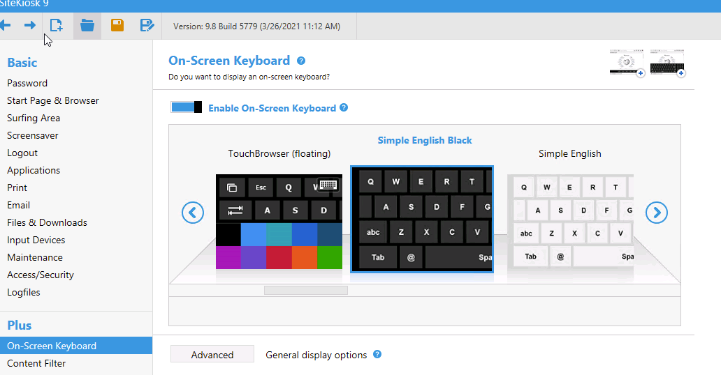

System Security Manager Settings
We need to configure SiteKiosk to give it and users the ability to access the kiosk software or it will fail to launch. This is done through the System Security Manager application installed by SiteKiosk.
First, launch SiteKiosk > System Security Manager from the Start menu.
Next, select the Customized permissions radio button from within System Security Manager and click OK. | 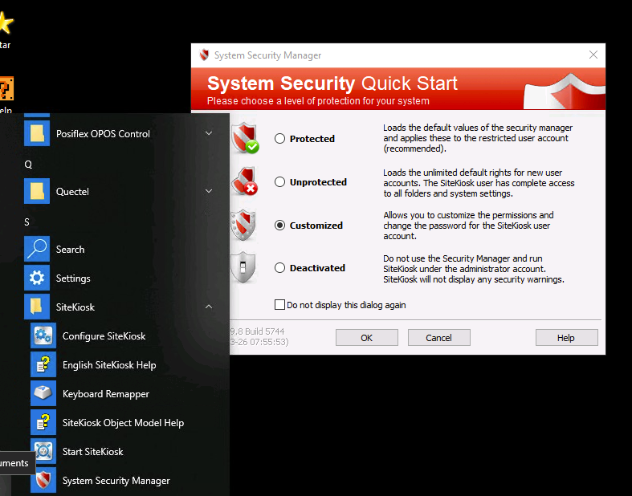

Under File System select the Folder Access node and highlight the C:\Program Files\FrontEdge\Kiosk folder. Click the Read & execute rights button and click Next through the rest of the wizard, leaving the defaults in place. | 